|  |  |
| --- | --- |
| COLOUR_LOGO Aug 2010 | **Year 12 *ATAR* Physics Unit 3** **2018**  ***Test 1 Projectile Motion, 3.0%***  **NAME: ………………………………………………….**  Data: See Data Sheet  Approx. marks shown.  ***(66 marks)*** |

When calculating numerical answers, show your working or reasoning clearly. Give final answers to **three** significant figures and include appropriate units where applicable.

When estimating numerical answers, show your working or reasoning clearly. Give final answers to a maximum of **two** significant figures and include appropriate units where applicable.

1. A cart that is rolling at constant velocity fires a ball straight up. Ignoring air resistance, when the ball comes back down, will it land in front of the launching tube, behind the launching tube, or directly in the tube? Explain. (3 marks)

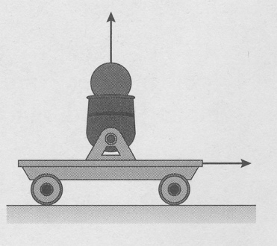

…………………………………………………………………………………………………….

…………………………………………………………………………………………………….

…………………………………………………………………………………………………….

…………………………………………………………………………………………………….

1. A golfer is teeing off on a 170.0 m long par 3 hole. The ball leaves with a velocity of 40.0 m s–1 at 50.0o to the horizontal. Assuming that she hits the ball on a direct path to the hole and that the hole is level with the tee,
2. how far from the hole will the ball land (no bounces or rolls)? (4 marks)

…………………………………………………………………………………………………….

…………………………………………………………………………………………………….

…………………………………………………………………………………………………….

…………………………………………………………………………………………………….

…………………………………………………………………………………………………….

…………………………………………………………………………………………………….

…………………………………………………………………………………………………….

…………………………………………………………………………………………………….

1. What is the maximum distance the ball can travel? (3 marks)

…………………………………………………………………………………………………….

…………………………………………………………………………………………………….

…………………………………………………………………………………………………….

…………………………………………………………………………………………………….

…………………………………………………………………………………………………….

…………………………………………………………………………………………………….

…………………………………………………………………………………………………….

…………………………………………………………………………………………………….

3. A fielder throws a baseball with a horizontal component of velocity of 25 m s–1. It takes 3.00 s to come back to its original height. Calculate

1. its horizontal range, (1 mark)

…………………………………………………………………………………………………….

…………………………………………………………………………………………………….

1. its initial vertical component of velocity, and (2 marks)

…………………………………………………………………………………………………….

…………………………………………………………………………………………………….

…………………………………………………………………………………………………….

…………………………………………………………………………………………………….

1. its initial angle(s) of projection. (3 marks)

…………………………………………………………………………………………………….

…………………………………………………………………………………………………….

…………………………………………………………………………………………………….

…………………………………………………………………………………………………….

4. The figure shows a skier that skis down a quarter-circle ramp, then off a cliff.

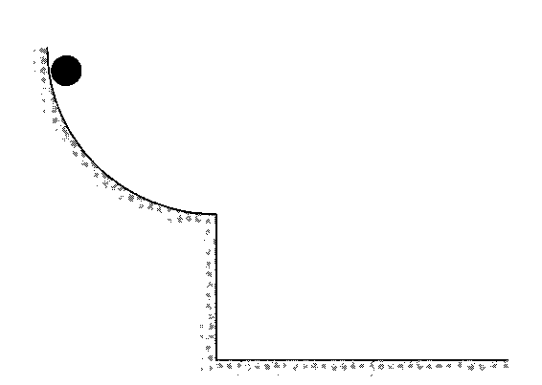

1. Sketch the skier's trajectory from the instant it is released until it hits the ground.

(2 marks)

1. The skier leaves the horizontal end of a ramp with a velocity of 25.0 m s–1 and lands 70.0 m from the base of the ramp. How high is the end of the ramp from the ground?

(3 marks)

…………………………………………………………………………………………………….

…………………………………………………………………………………………………….

…………………………………………………………………………………………………….

…………………………………………………………………………………………………….

…………………………………………………………………………………………………….

…………………………………………………………………………………………………….

1. Determine the skier’s velocity 2.0 s after leaving the end of the ramp. (4 marks)

…………………………………………………………………………………………………….

…………………………………………………………………………………………………….

…………………………………………………………………………………………………….

…………………………………………………………………………………………………….

…………………………………………………………………………………………………….

…………………………………………………………………………………………………….

…………………………………………………………………………………………………….

…………………………………………………………………………………………………….

5. A rock is thrown from a bridge 15.0 m high at an angle 30.0° below horizontal. Ignore air resistance.

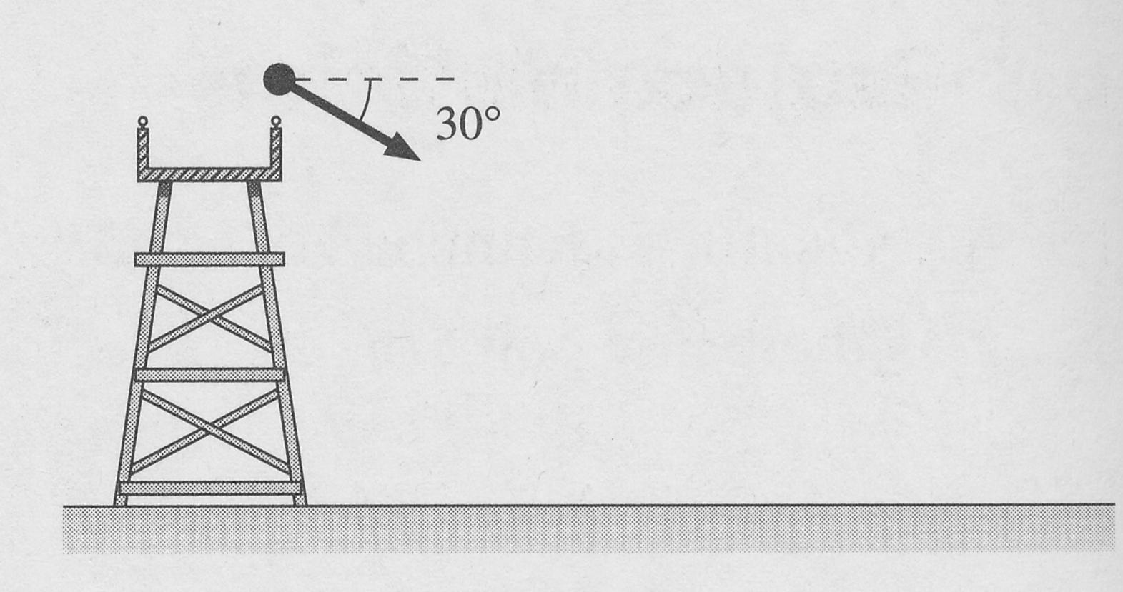

(a) Sketch the rock's trajectory on the figure. (1 mark)

(b) (i) Immediately after the rock is released, is the magnitude of its acceleration greater than, less than, or equal to *g*? Explain. (1 mark)

…………………………………………………………………………………………………….

…………………………………………………………………………………………………….

(ii) Just before impact with the ground, is the magnitude of its acceleration greater than, less than, or equal to *g*? Explain. (1 mark)

…………………………………………………………………………………………………….

…………………………………………………………………………………………………….

(c) The rock lands at a horizontal distance of 25.6 m from the bridge. Calculate the speed at which the rock is thrown. (4 marks)

…………………………………………………………………………………………………….

…………………………………………………………………………………………………….

…………………………………………………………………………………………………….

…………………………………………………………………………………………………….

…………………………………………………………………………………………………….

…………………………………………………………………………………………………….

…………………………………………………………………………………………………….

…………………………………………………………………………………………………….

…………………………………………………………………………………………………….

…………………………………………………………………………………………………….

1. An astronaut stands on the edge of an asteroid crater and uses a launcher to project an object with a velocity of 5.00 m s–1 at an angle of 65.0° above horizontal. The floor of the crater is 100.0 m below the astronaut. The object travels a horizontal distance of 55.3 m before hitting the floor of the crater. There is no atmosphere on the asteroid.
2. Determine the acceleration of gravity on the asteroid. (4 marks)

…………………………………………………………………………………………………….

…………………………………………………………………………………………………….

…………………………………………………………………………………………………….

…………………………………………………………………………………………………….

…………………………………………………………………………………………………….

…………………………………………………………………………………………………….

…………………………………………………………………………………………………….

…………………………………………………………………………………………………….

…………………………………………………………………………………………………….

…………………………………………………………………………………………………….

1. How high above the crater floor did the object rise? (3 marks)

…………………………………………………………………………………………………….

…………………………………………………………………………………………………….

…………………………………………………………………………………………………….

…………………………………………………………………………………………………….

…………………………………………………………………………………………………….

…………………………………………………………………………………………………….

7. Paul kicks a ball from point P to point R. At the same instant, Quinn starts from point Q and runs forward, to catch the ball at point R. The horizontal distance between P and Q when Paul kicks the ball is 15.0 m. The initial vertical velocity (uv) of the ball is 12.0 m s–1 and its horizontal velocity (uh) is 10.0 m s–1. Ignore air resistance throughout this question.

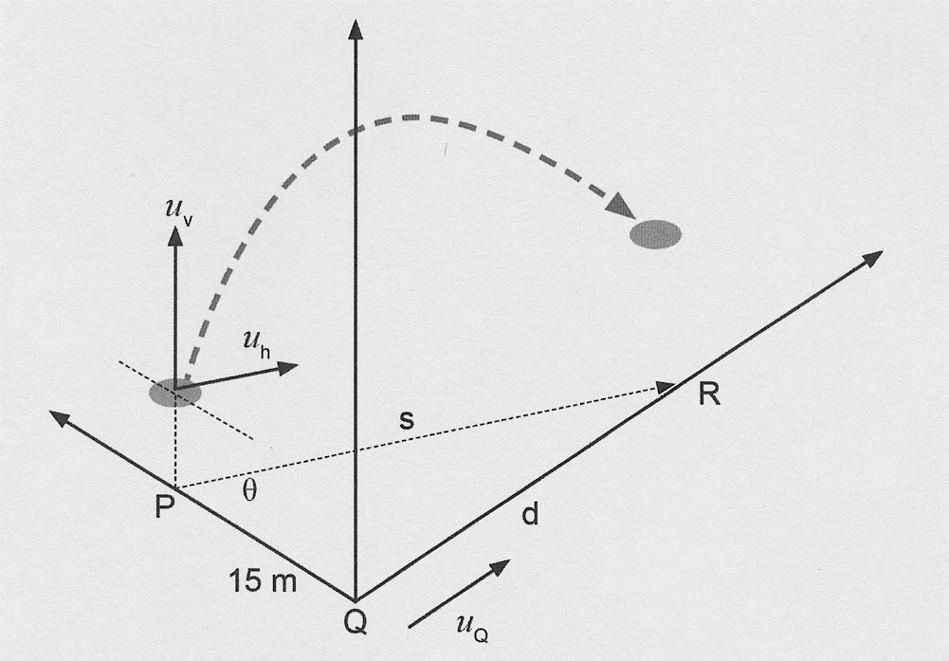

(a) Calculate the initial velocity of the ball. (3 marks)

…………………………………………………………………………………………………….

…………………………………………………………………………………………………….

…………………………………………………………………………………………………….

…………………………………………………………………………………………………….

…………………………………………………………………………………………………….

Paul kicks the ball 1.00 m above the ground. Quinn jumps and catches the ball when it is 3.00 m above the ground at point R.

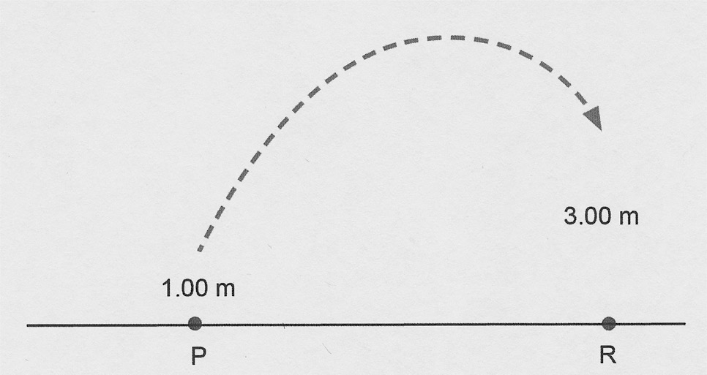

(b) (i) Show by calculation that the total time taken by the ball in the air to get from 1.00 m above the ground to 3.00 m above the ground could be either about 0.2 s or about 2.3 s. (4 marks)

…………………………………………………………………………………………………….

…………………………………………………………………………………………………….

…………………………………………………………………………………………………….

…………………………………………………………………………………………………….

…………………………………………………………………………………………………….

…………………………………………………………………………………………………….

…………………………………………………………………………………………………….

…………………………………………………………………………………………………….

…………………………………………………………………………………………………….

…………………………………………………………………………………………………….

(ii) Which of these two calculated time values in part (b) (i) is more appropriate for the ball to travel to Quinn? State a reason why. (2 marks)

…………………………………………………………………………………………………….

…………………………………………………………………………………………………….

…………………………………………………………………………………………………….

…………………………………………………………………………………………………….

…………………………………………………………………………………………………….

(c) Determine the horizontal distance (*s*) the ball will cover before Quinn catches it at

point R. (2 marks)

…………………………………………………………………………………………………….

…………………………………………………………………………………………………….

…………………………………………………………………………………………………….

(d) Determine the average speed at which Quinn would need to travel from point Q to be able to catch the ball at point R. (3 marks)

…………………………………………………………………………………………………….

…………………………………………………………………………………………………….

…………………………………………………………………………………………………….

…………………………………………………………………………………………………….

…………………………………………………………………………………………………….

…………………………………………………………………………………………………….

(e) If the ball were to be kicked from the ground, determine the ground angle (θ), as shown on the diagram below, at which Paul needs to kick the ball so that the ball has the same velocity at position P as originally stated. (4 marks)



1.00 m

*θ*

…………………………………………………………………………………………………….

…………………………………………………………………………………………………….

…………………………………………………………………………………………………….

…………………………………………………………………………………………………….

…………………………………………………………………………………………………….

…………………………………………………………………………………………………….

8. (a) Rank in order, from shortest to longest, the amount of time it takes each of these projectiles to hit the ground. Ignore air resistance. (Some may be simultaneous.)

(3 marks)

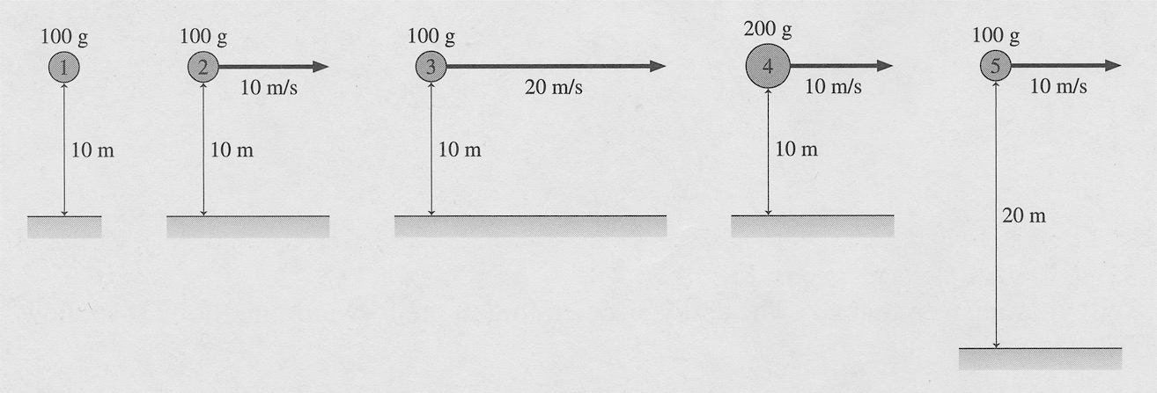

…………………………………………………………………………………………………….

…………………………………………………………………………………………………….

(b) Rank in order, from shortest to longest, the amount of time it takes each of these projectiles to hit the ground. Consider air resistance. (Some may be simultaneous.)

Explain your answer. (3 marks)

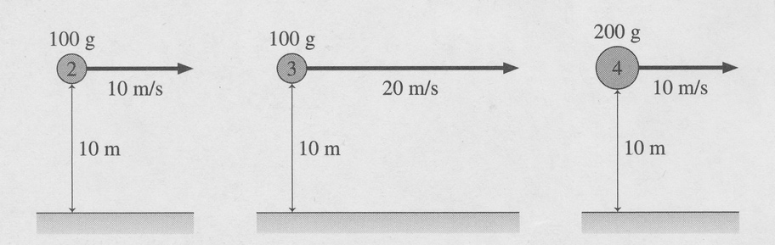

…………………………………………………………………………………………………….

…………………………………………………………………………………………………….

…………………………………………………………………………………………………….

…………………………………………………………………………………………………….

…………………………………………………………………………………………………….

…………………………………………………………………………………………………….

1. Consider the picture below.

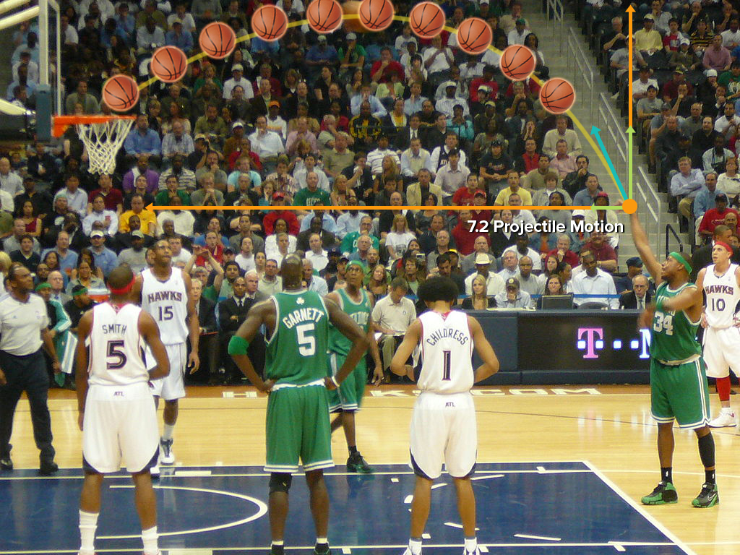

The basketball is launched with the velocity shown by the green arrow indicated. However the height of the trajectory of the basketball is less than the ideal height but it travels the same range as the ideal range. How can this path of the basketball be explained. (3 marks)

…………………………………………………………………………………………………….

…………………………………………………………………………………………………….

…………………………………………………………………………………………………….

…………………………………………………………………………………………………….

…………………………………………………………………………………………………….

…………………………………………………………………………………………………….

Extras

Purple Randle D Knight pg 6.5, 6.6 Q9

9. A projectile is launched over horizontal ground at an angle between 0° and 90°.

a. Is there any point on the trajectory where i; and Ft are parallel to each other? If so, where?

b. Is there any point where f; and a are perpendicular to each other? If so, where?

c. Which of the following remain constant throughout the entire trajectory: r, x, y, v, vx,vy, ax, ay?



c. At the instant of impact, is the rock's speed greater than, less than, or equal to the speed with which it was thrown? Explain.

Purple Randle D Knight pg 6.5, 6.6 Q13

13. Four balls are simultaneously launched with the same speed from the same height h above the ground. At the same instant, ball 5 is released from rest at the same height. Rank in order, from shortest to longest, the amount of time it takes each of these balls to hit the ground. Ignore air resistance. (Some may be simultaneous.)

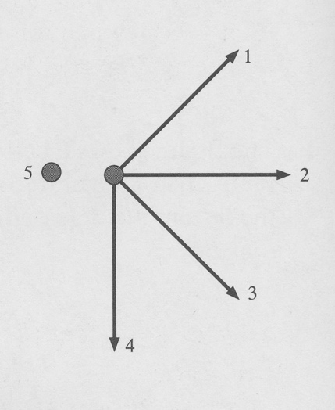

Order:

Explanation:

http://www.mlbgsd.k12.pa.us/cms/lib/PA09000085/Centricity/Domain/83/040927ProjectileMotReview.pdf Q5 Worksheet

5. A diver jumps UP off a pier at an angle of 25° with an initial velocity of 3.2 m s–1. How far from the pier will the diver hit the water (Assume the level of water is the same as the pier)

(4 marks)

…………………………………………………………………………………………………….

…………………………………………………………………………………………………….

…………………………………………………………………………………………………….

…………………………………………………………………………………………………….

…………………………………………………………………………………………………….

…………………………………………………………………………………………………….

…………………………………………………………………………………………………….